**Coursera Capstone**

IBM Applied Data Science Capstone

**Opening a New Japanese Restaurant in Ann Arbor, Michigan**

By: Tom Tian

November 2019

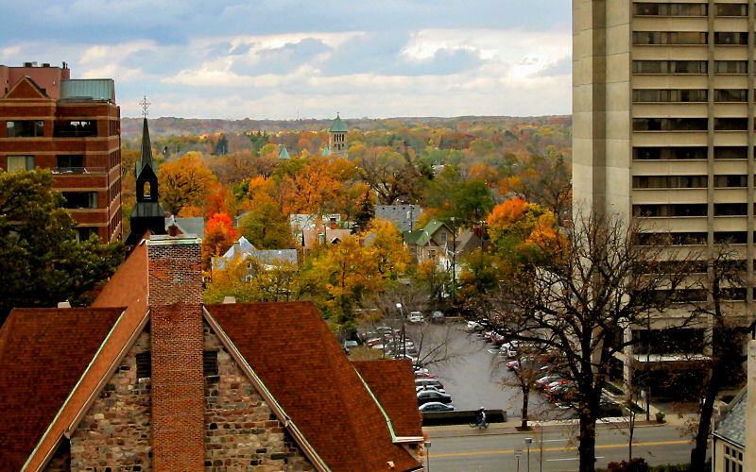

**Introduction**

For many investors or entrepreneurs, opening a Japanese restaurant in a culture diversified neighborhood normally provides good return in investment. Same as all other business decisions, opening a restaurant requires serious consideration and it may be lot more complicated than it seems. Particularly, the location of the restaurant is one of the most important factors that will determine whether the restaurant will be a success or a failure.

The objective of this capstone project is to analyze and select the best locations in the city of Ann Arbor, Michigan to open a new Japanese restaurant, where is the highly rated University of Michigan located. Using data science methodology and machine learning techniques like clustering, this project aims to provide best possible locations can be chosen by stakeholders. Since there are many restaurants in Ann Arbor we will try to detect locations that are not already crowded with Japanese restaurants or with no Japanese restaurants at all.

## Data

To solve the problem, we will need the following data:

* The number of existing Asian restaurants in Ann Arobor, Michigan.
* The number of Japanese restaurants in the city.
* Latitude and longitude coordinates of the neighborhoods. This is required in order to plot the map and to get the venue data.
* Venue data, particularly data related to restaurants. We will use this data to perform clustering on the neighborhoods.

Sources of data and methods to extract them:

The center of the city will be obtained using Google Maps API geocoding.

The centers of candidate areas will be generated algorithmically and approximate addresses of centers of those areas will be obtained using Google Maps API reverse geocoding.

The number of restaurants and the venue data for those neighborhoods will be obtained using Foursquare API. Foursquare has one of the largest databases of 105+ million places and is used by over 125,000 developers. Foursquare API will provide many categories of the venue data, we are particularly interested in the Asian Restaurant category in order to help us to solve this particular business problem. This is a project that will make use of many data science skills such as working with API (Foursquare), data cleaning, data wrangling, to machine learning (K-means clustering) and map visualization (Folium).

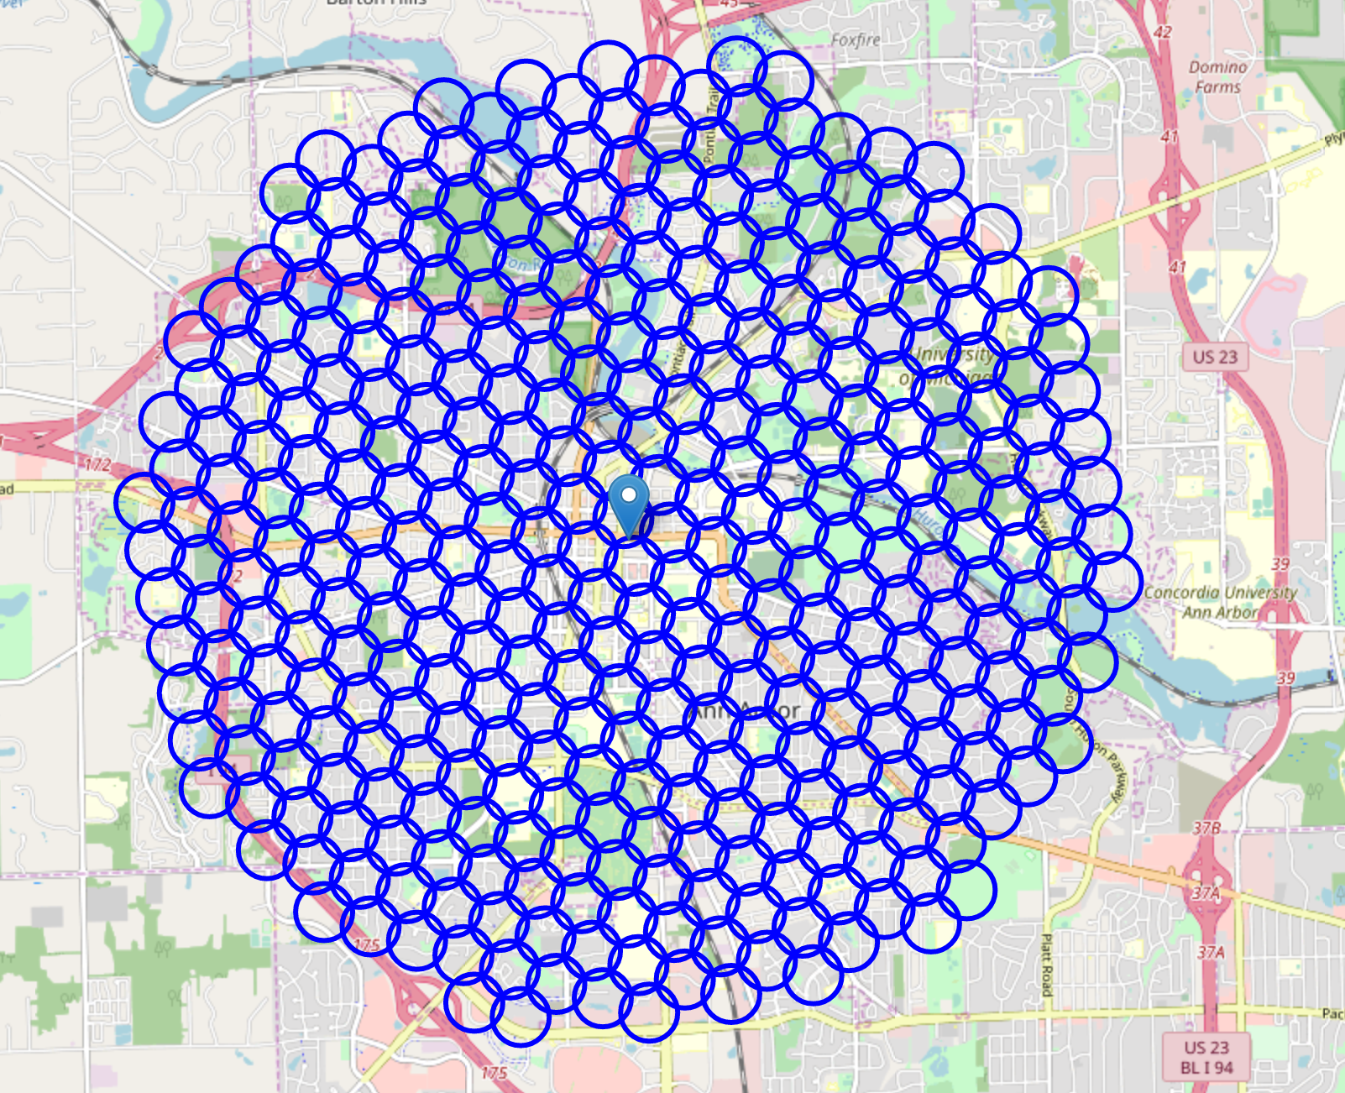

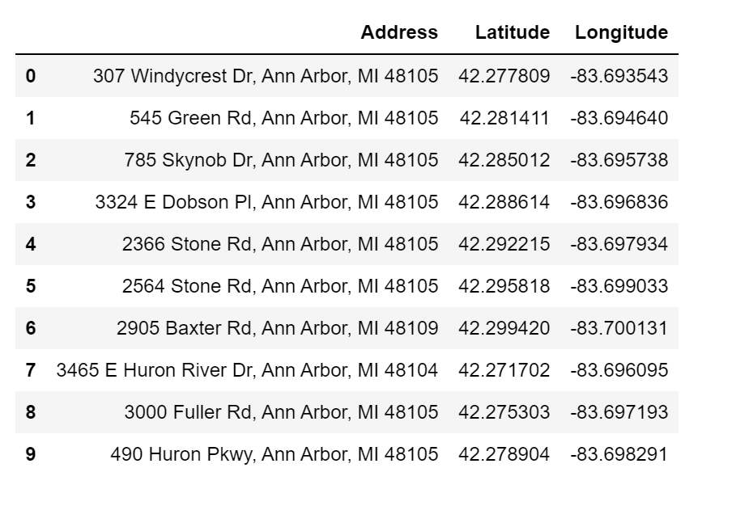

## Methodology

Firstly, we use the Google Map API to decide the latitude and longitude of the city center. After gathering the data, we will populate the data into a pandas Data Frame and then visualize the neighborhoods in a map using Folium package. This allows us to perform a sanity check to make sure that the geographical coordinates data returned by Google Map API are correctly plotted in the city of Ann Arbor.

Next, we use Foursquare API to get all the Asian restaurants and Japanese restaurants within a radius of 6000 meters of the city center based on the Foursquare categories. We then make API calls to Foursquare passing in the geographical coordinates of the neighborhoods in a Python loop. Foursquare will return the venue data in JSON format and we will extract the venue name, venue category, venue latitude and longitude. By doing so, we are also preparing the data for use in clustering. Since we are analyzing the Japanese restaurant data, we will filter the Japanese restaurant as venue category for the neighborhoods.

Last, we will perform clustering on the data by using k-means clustering. K-means clustering algorithm identifies k number of centroids, and then allocates every data point to the nearest cluster, while keeping the centroids as small as possible. It is one of the simplest and popular unsupervised machine learning algorithms and is particularly suited to solve the problem for this project. We will cluster the neighborhoods into 4 clusters based on their frequency of occurrence for Asian Restaurants. The results will allow us to identify which neighborhoods have higher concentration of Japanese restaurants. Based on the occurrence of Japanese restaurants in different neighborhoods, it will help us to answer the question as to which neighborhoods are most suitable to open a new Japanese restaurant. We also present the recommended regions on the map using folium.

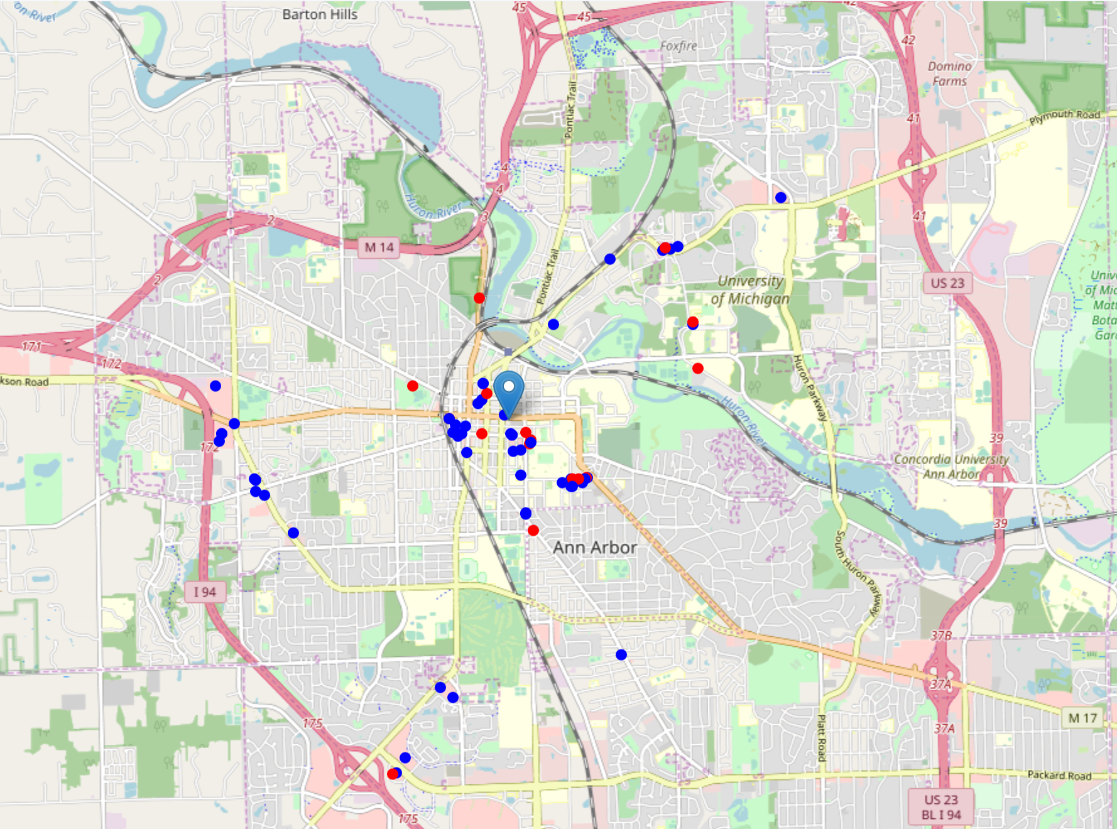

## Results

The results from the k-means clustering show that we can categorize the neighborhoods into 4 clusters based on the frequency of occurrence for Asian restaurants. It shows that the west campus of the city has the lowest density of Japanese restaurants.

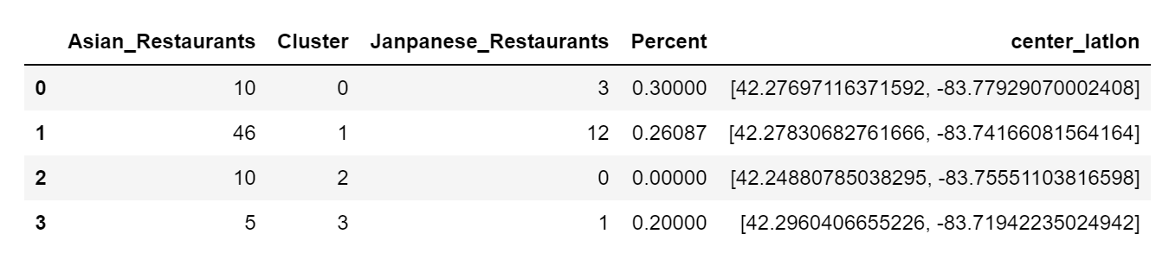

**Discussion**

From the results of the clustering are visualized in the map, most of the Asian restaurants are concentrated in the central area of the city of Ann Arbor. Around 20% - 30% of the restaurants in the central area, north suburb, and south suburb are Japanese restaurants among all the Asian restaurants in each area. The west suburb in the neighborhoods have 10 Asian restaurants but has no Japanese restaurant, which represents a great opportunity and a high potential area to open new Japanese restaurants as there is very little to no competition from existing business.

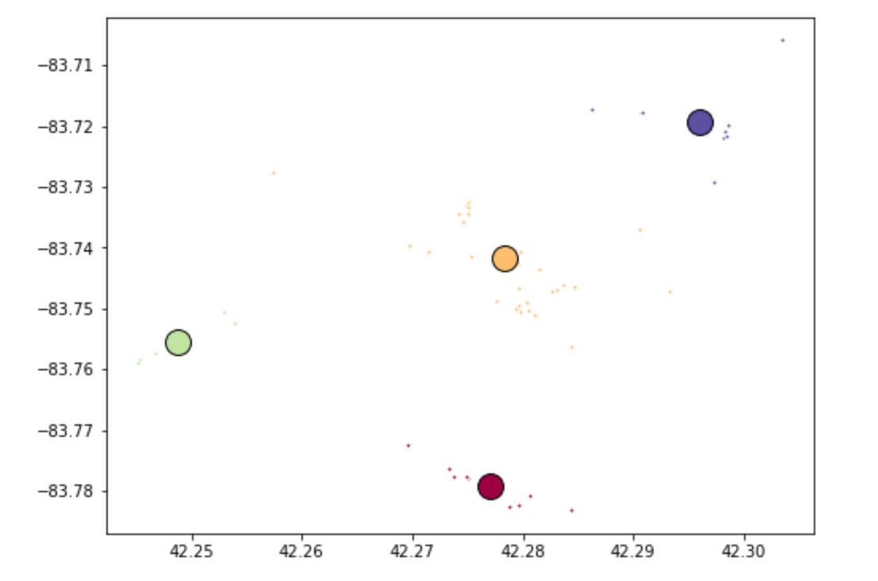

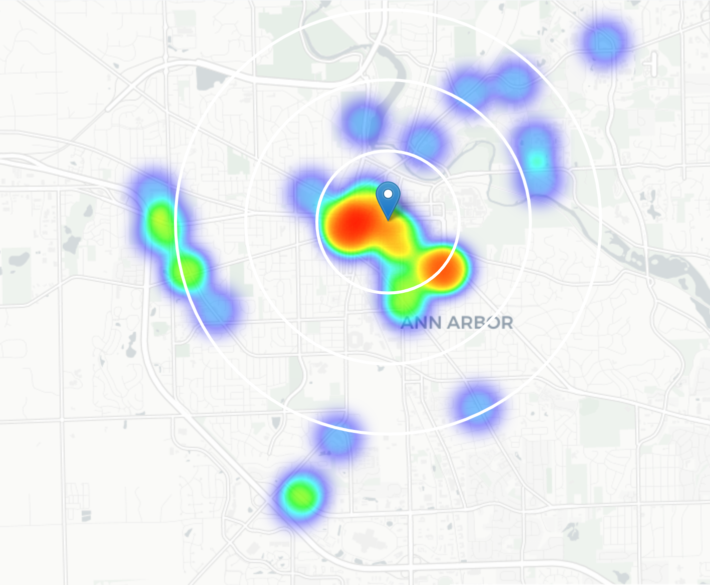

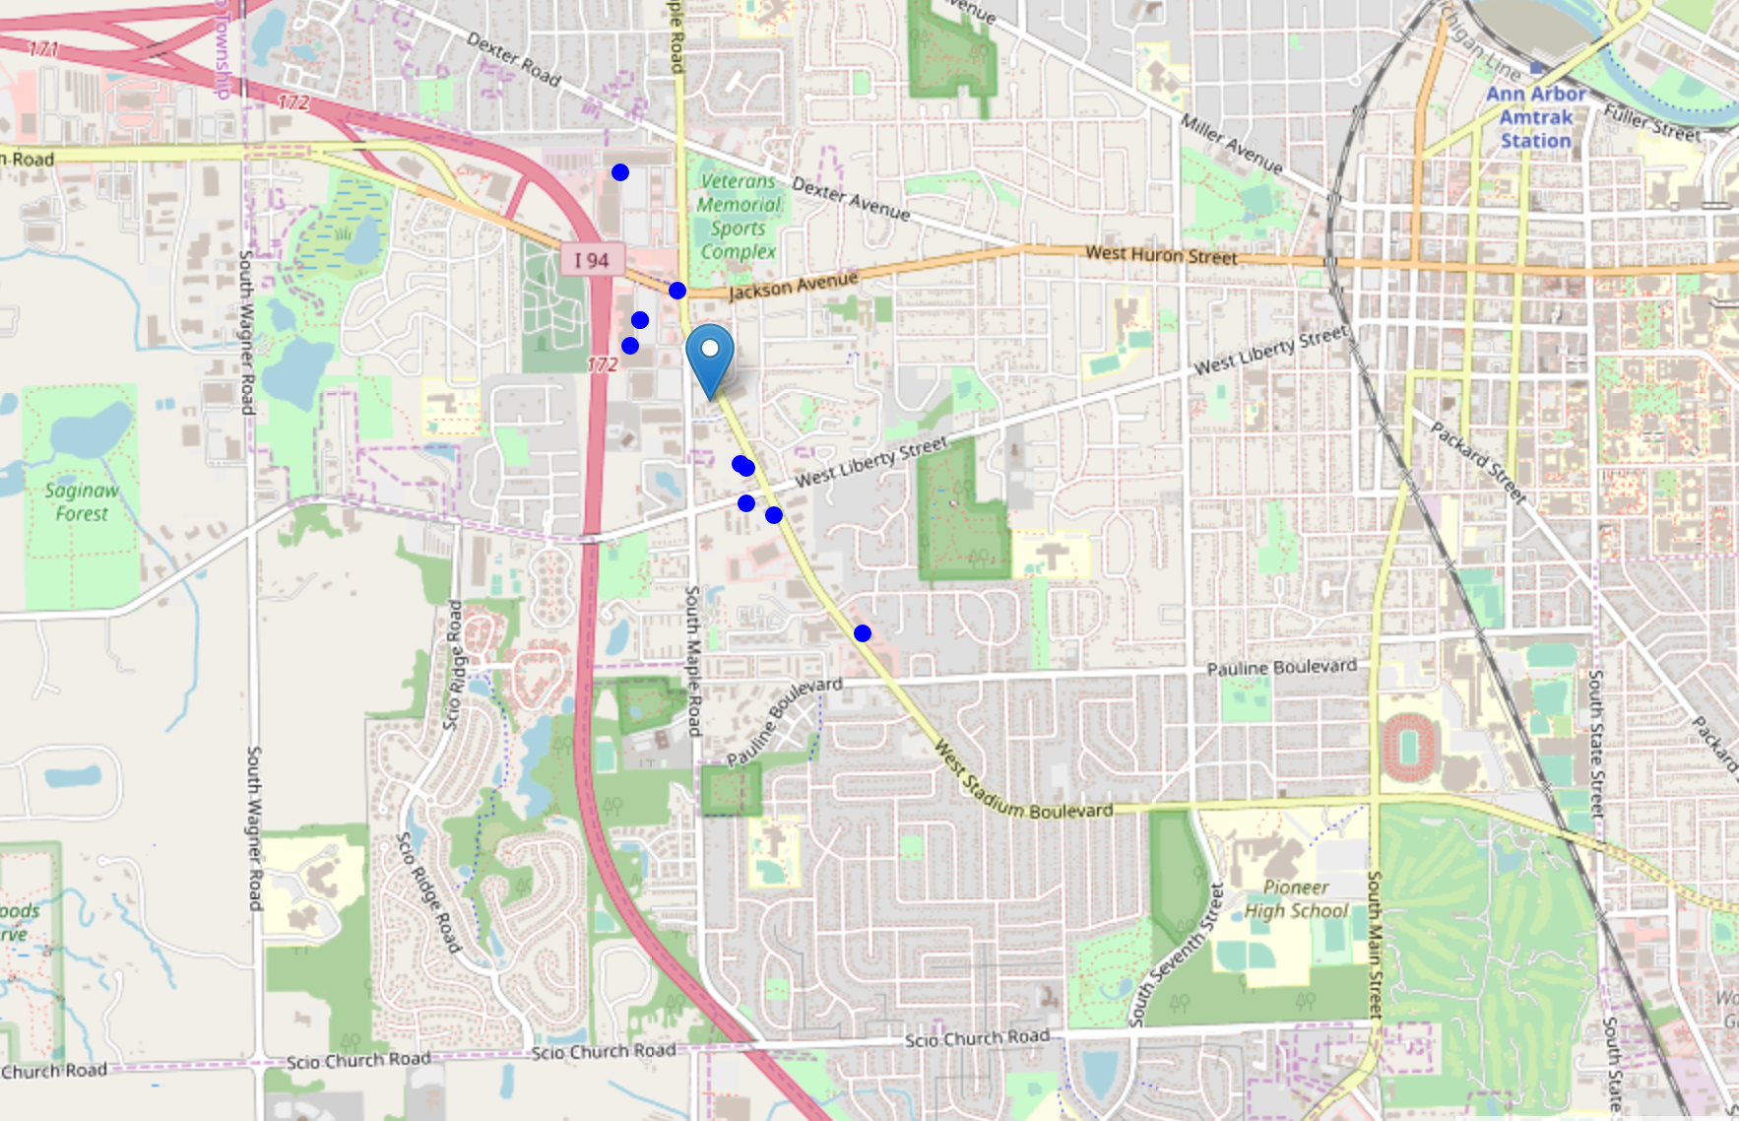

## Conclusion

In this project, we have gone through the process of identifying the business problem, specifying the data required, preparing and cleaning the data, performing machine learning by clustering the data into 4 clusters based on their similarities, and lastly providing recommendations to the relevant investors regarding the best locations to open a new Japanese restaurant. To answer the business question that was raised in the introduction section, the answer proposed by this project is: The neighborhood in the west suburb of Ann Arbor is the most preferred location to open a new Japanese restaurant. The findings of this project will help the relevant stakeholders to capitalize on the opportunities on high potential locations while avoiding overcrowded areas in their decisions to open a new Japanese restaurant.

In this project, we only consider one factor i.e. frequency of occurrence of Japanese restaurants, there are other factors such as Japanese population and income of residents that could influence the location decision of a new Japanese restaurant. However, to the best knowledge of this researcher such data are not available to the neighborhood level required by this project. Future research could devise a methodology to estimate such data to be used in the clustering algorithm to determine the preferred locations to open a new Japanese restaurant. In addition, this project made use of the free individual account of Foursquare API that came with limitations as to the number of API calls and results returned. Future research could make use of paid account to bypass these limitations and obtain more results.